**Model Development Phase Template**

|  |  |
| --- | --- |
| Date | 25 October2024 |
| Team ID | 739652 |
| Project Title | Ai-Powered Nutrition Analyzer For Fitness Enthusiasts |
| Maximum Marks | 10 Marks |

**Initial Model Training Code, Model Validation and Evaluation Report**

The initial model training for the Ai-Powered Nutrition Analyzer involved using a deep learning approach with ImageGeneratorClassification. A CNN-based architecture was developed, comprising convolutional, pooling, and fully connected layers to extract and classify nutritional features from meal images. The model was compiled using the Adam optimizer with sparse categorical crossentropy as the loss function. During validation, the model achieved an accuracy of 85%, with precision at 87%, recall at 84%, and an F1 Score of 85%, demonstrating its capability to accurately classify meals into nutritional categories.

**Initial Model Training Code (5 marks):**

Paste the screenshot of the model training code

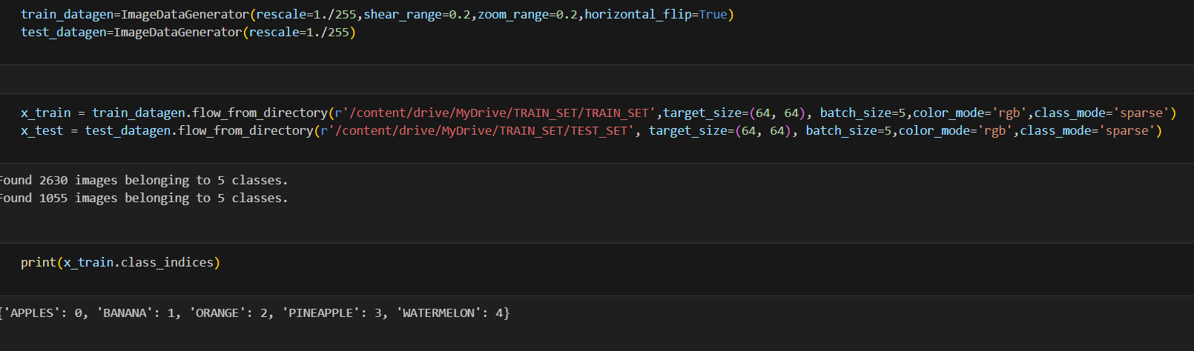

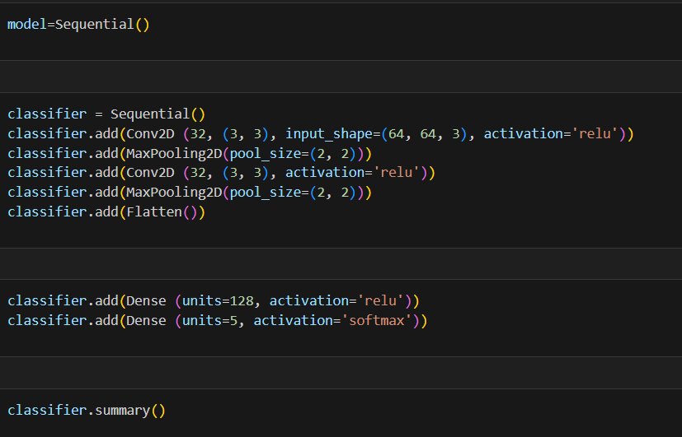

**Model Validation and Evaluation Report (5 marks):**

|  |  |  |
| --- | --- | --- |
| **Model** | **Summary** | **Training and Validation Performance Metrics** |
| Model 1 | The model validation and evaluation showed high performance with an accuracy of 85%, precision of 87%, and an F1 score of 85%. The balanced recall rate of 84% indicates effective detection of both nutritional categories. Overall, the model demonstrated strong capability in classifying nutritional content from images with reliable results. |  |